**1.(a) Get the project up and running locally.**

1. After creating your simple maven project, run ***mvn clean install*** to download all the dependencies.

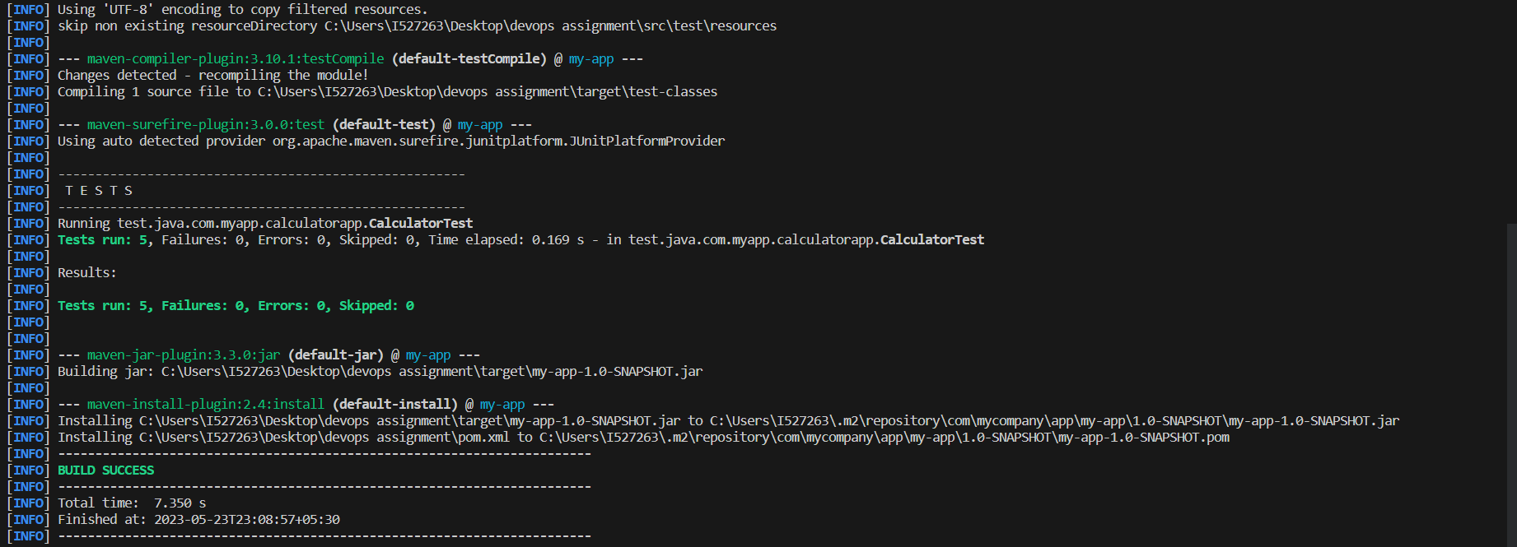

2. Run your application by choosing **Run->Run Without Debugging** from the top menu.

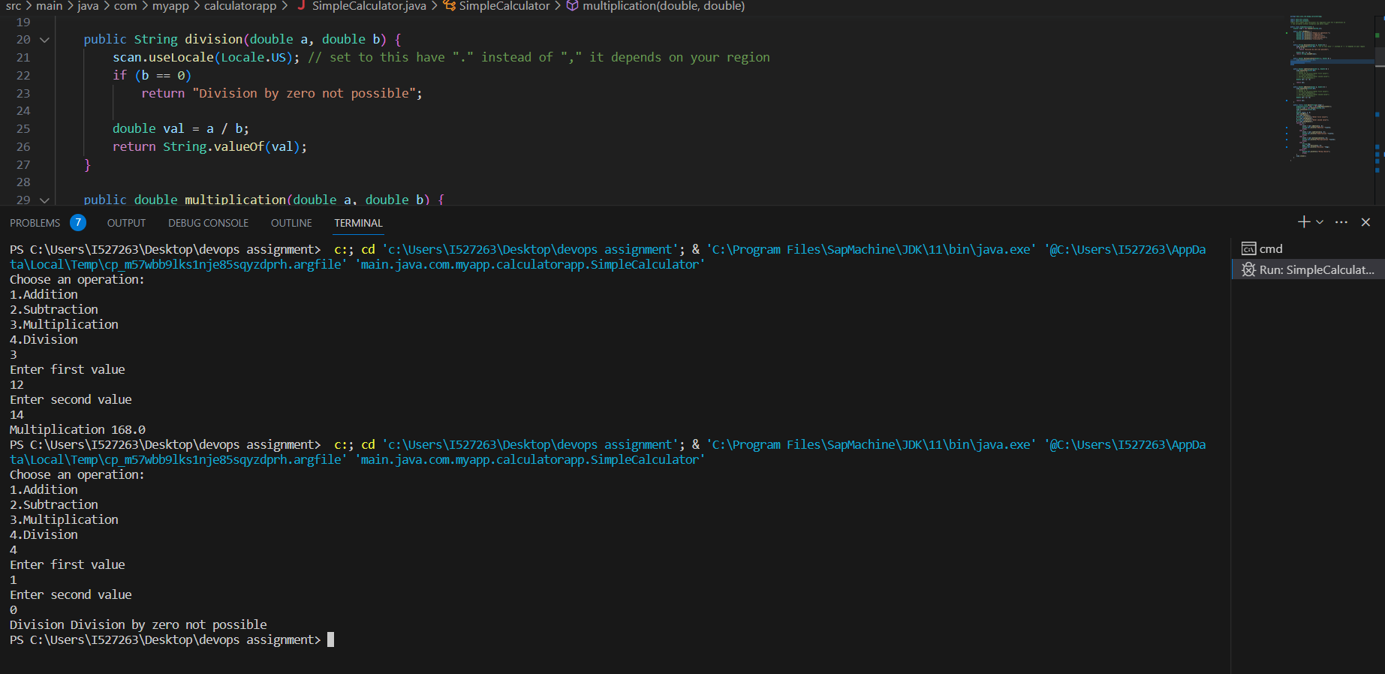

**1.(b) Build an initial CI pipeline on Github.**

1. Create an empty Git repository on Github.

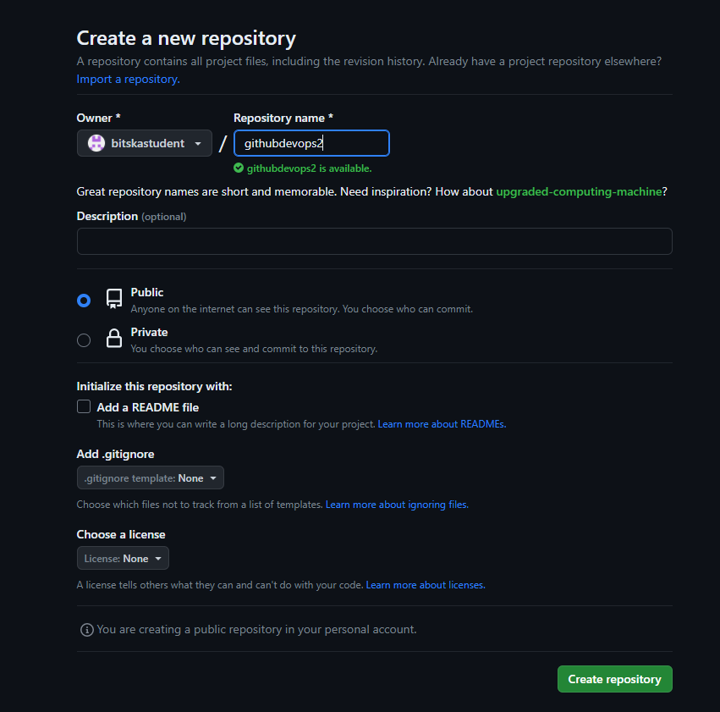

1. Firstly, initialize the empty git repository in your project folder. (git init)
2. Then add untracked files to your staging area. (git add .)
3. Commit the files to your local repository. (git commit -m <>)
4. Set origin and upstream to the remote repository.
5. Push the code to the remote repository.

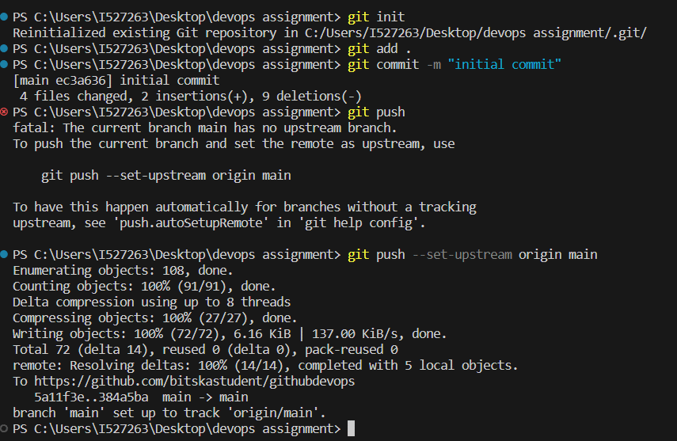



1. In your repository, click on Actions tab and choose the 1st option.

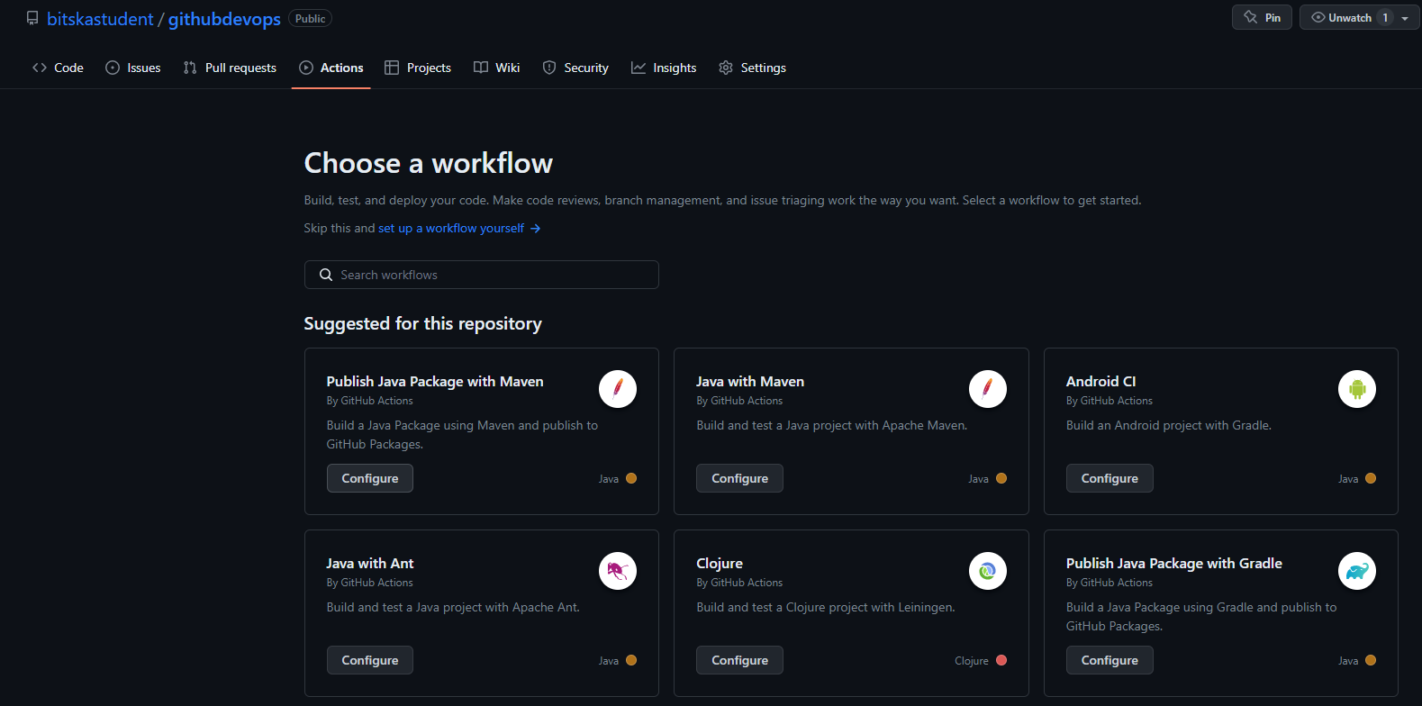

1. Add the code in the maven.yaml as follows.

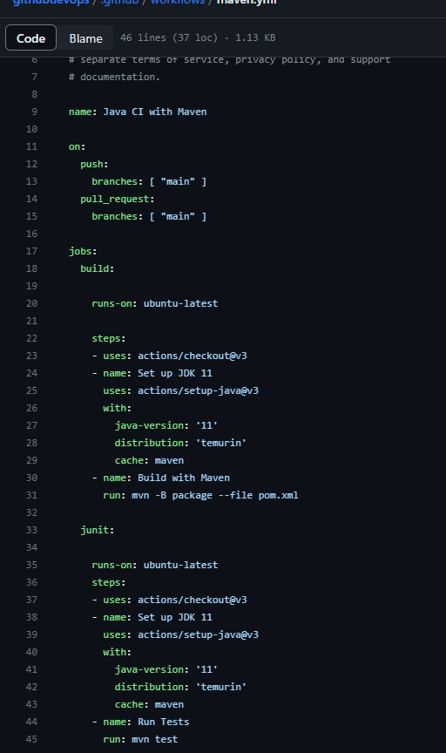

1. Finally committing the yaml file to the main branch (make sure you select the option in the commit changes button), your job will run and the pipeline will pass as follows.

